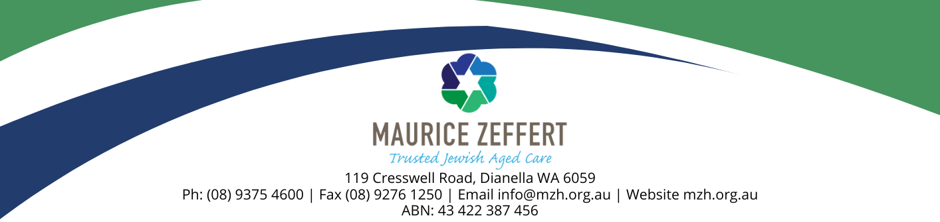

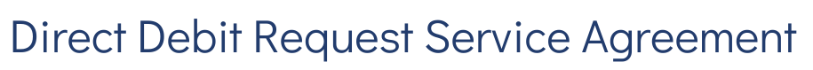

This is your Direct Debit Service Agreement with MAURICE ZEFFERT HOME (INC), User ID: 483570, ABN: 43 422 387 456. It explains what your obligations are when undertaking a Direct Debit arrangement with us. It also details what our obligations are to you as your Direct Debit Provider.
Please keep this agreement for future reference. It forms part of the terms and conditions of your Direct Debit Request (DDR) and should be read in conjunction with your DDR authorisation.
Definitions | - account means the account held at your financial institution from which we are authorised to arrange for funds to be debited.  - agreement means this Direct Debit Request Service Agreement between you and us.  - banking day means a day other than a Saturday or a Sunday or a public holiday listed throughout Australia.  - debit day means the day that payment by you to us is due.  - debit payment means a particular transaction where a debit is made.  - direct debit request means the Direct Debit Request between us and you.  - us or we means MAURICE ZEFFERT HOME (INC), (the Debit User) you have authorised by requesting a Direct Debit Request.  - you means the customer who has signed or authorised by other means the Direct Debit Request.  - your financial institution means the financial institution nominated by you on the DDR at which the account is maintained.
- Debiting your account | - By signing a Direct Debit Request or by providing us with a valid instruction, you have authorised us to arrange for funds to be debited from your account. You should refer to the Direct Debit Request and this agreement for the terms of the arrangement between us and you.  - We will only arrange for funds to be debited from your account as authorised in the Direct Debit Request.  or  We will only arrange for funds to be debited from your account if we have sent to the address nominated by you in the Direct Debit Request, a billing advice which specifies the amount payable by you to us and when it is due.  - If the debit falls on a day that is not a banking day, we may direct your financial institution to debit your account on the following banking day. If you are unsure about which day your account has or will be debited you should ask your financial institution.
- Amendments by us | - We may vary any details of this agreement or a Direct Debit Request at any time by giving you at least fourteen (14) days written notice.
- Amendments by you | - You may change*, stop or defer a debit payment, or terminate this agreement by providing us with at least fourteen (14) days notification by writing to:  MAURICE ZEFFERT HOME (INC) ACCOUNTS DEPARTMENT  119 CRESSWELL ROAD,  DIANELLA WA 6059  or  by emailing us at accounts@mzh.org.au  or  by telephoning us on (08) 9375 4600 during business hours;  or  arranging it through your own financial institution, which is required to act promptly on your  instructions.  *Note: in relation to the above reference to ‘change’, your financial institution may ‘change’ your  debit payment only to the extent of advising us MAURICE ZEFFERT HOME (INC)  your new account details.

- Your obligations | - It is your responsibility to ensure that there are sufficient clear funds available in your account to allow a debit payment to be made in accordance with the Direct Debit Request.  - If there are insufficient clear funds in your account to meet a debit payment:  - you may be charged a fee and/or interest by your financial institution;  - you may also incur fees or charges imposed or incurred by us; and  - you must arrange for the debit payment to be made by another method or arrange for sufficient clear funds to be in your account by an agreed time so that we can process the debit payment.  - You should check your account statement to verify that the amounts debited from your account are correct.
- Dispute | - If you believe that there has been an error in debiting your account, you should notify us directly on (08) 9375 4600 and confirm that notice in writing with us as soon as possible so that we can resolve your query quickly. Alternatively you can take it up directly with your financial institution.  - If we conclude as a result of our investigations that your account has been incorrectly debited we will respond to your query by arranging for your financial institution to adjust your account (including interest and charges) accordingly. We will also notify you in writing of the amount by which your account has been adjusted.  - If we conclude as a result of our investigations that your account has not been incorrectly debited we will respond to your query by providing you with reasons and any evidence for this finding in writing.
- Accounts | You should check:  - with your financial institution whether direct debiting is available from your account as direct debiting is not available on all accounts offered by financial institutions.  - your account details which you have provided to us are correct by checking them against a recent account statement; and  - with your financial institution before completing the Direct Debit Request if you have any queries about how to complete the Direct Debit Request.
- Confidentiality | - We will keep any information (including your account details) in your Direct Debit Request confidential. We will make reasonable efforts to keep any such information that we have about you secure and to ensure that any of our employees or agents who have access to information about you do not make any unauthorised use, modification, reproduction or disclosure of that information.  - We will only disclose information that we have about you:  - to the extent specifically required by law; or  - for the purpose of this agreement (including disclosing information in connection with any query or claim).
- Notice | - If you wish to notify us in writing about anything relating to this agreement, you should write to  ACCOUNTS DEPARTMENT  MAURICE ZEFFERT HOME (INC)  119 CRESSWELL ROAD, DIANELLA WA 6059  Or  Email to accounts@mzh.org.au  - We will notify you by sending a notice in the ordinary post to the address you have given us in the Direct Debit Request.  - Any notice will be deemed to have been received on the third banking day after posting.

